San Juan County
Family Resource Guide

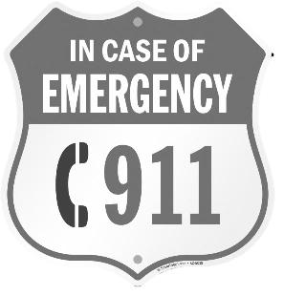
Emergency Numbers
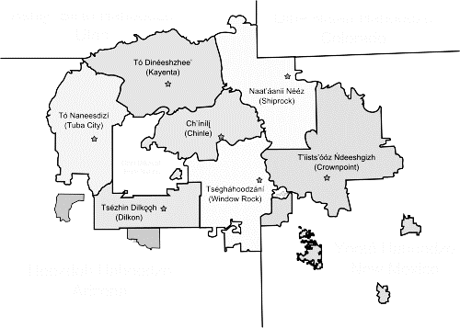
Fire, Police, Ambulance dial 9-1-1
- If on the Navajo Reservation, 9-1-1 will route to Shiprock Police Department or nearest Navajo Nation PD
24-hour Emergency Calls, San Juan County Dispatch
435-587-2237
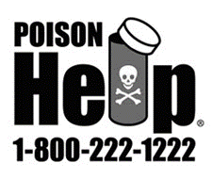
Poison Control 1-800-222-1222
National Suicide Prevention Lifeline
- 1-800-273-TALK (8255) or
- text “START” to 741741
San Juan Crisis/Suicide Prevention
435-678-2992; after hours, 1-800-273-8255
Navajo Nation:
- Kayenta Police Department 928-697-5600
- Shiprock Police Department 505-368-1350
Montezuma Creek:
- Fire and Ambulance Station 435-651-3351

City of Blanding:
- Blanding City Office 435-678-2791 After hours emergencies, call 435-678-2916
- Blanding Police (Business line) 435-678-2334

City of Monticello:
- Monticello City Office 435-587-2271 After Hours, call 435-459-0078
- Monticello Public Works Emergency: 435-459-9202
- Monticello Police Department, (San Juan County dispatch) 435-587-2237
Table of Contents:
Abuse ----------------------------------------------------------------------------------------------------------- 4 - 5
Adoption ------------------------------------------------------------------------------------------------------- 6
Adult Education ---------------------------------------------------------------------------------------------- 7
Children, Youth & Family Services ---------------------------------------------------------------------- 8 - 9
Counseling, Mental Health and Support Group Resources --------------------------------------- 10 - 13
Courts/Legal Aid --------------------------------------------------------------------------------------------- 14 - 15
Disability Support Services -------------------------------------------------------------------------------- 16
Drug, Alcohol, and Tobacco resources ----------------------------------------------------------------- 17
Employment and Job training ---------------------------------------------------------------------------- 18
Financial Services -------------------------------------------------------------------------------------------- 19
Food Assistance --------------------------------------------------------------------------------------------- 20 - 21
Government Services -------------------------------------------------------------------------------------- 22
Health ---------------------------------------------------------------------------------------------------------- 23 - 29
Hospitals, Clinics & Pharmacies ------------------------ 23 - 24
Dental & Vision -------------------------------------------- 24
Home Care -------------------------------------------------- 25
Insurance ---------------------------------------------------- 25 - 26
Physical Therapy ------------------------------------------- 27
Pregnancy ---------------------------------------------------- 27 - 28
Transportation --------------------------------------------- 29
Housing -------------------------------------------------------------------------------------------------------- 30
Libraries ------------------------------------------------------------------------------------------------------- 31
Schools -------------------------------------------------------------------------------------------------------- 32 - 35
Tribal Services ----------------------------------------------------------------------------------------------- 36 - 38
If anyone is in imminent danger, or
To report violence in progress,
Dial 9-1-1

Adult Protective Services (APS), Utah
1-800-371-7897
https://daas.utah.gov

Division of Child and Family Services (DCFS), Blanding
435-678-1491
https://dcfs.utah.gov

San Juan County Victim Advocate
435-210-2406

Seekhaven Family Crisis & Resource Center
435-259-2229
https://www.seekhaven.org/

Tohdenasshai Shelter Home (Kayenta)
24/7 hotline 1-877-697-8591

UNHS Victim Advocate
24-hour hotline 435-678-0249 or 435-651-3762

Utah Child Protective Services (CPS)
Reporting line 1-855-323-3237
https://dcfs.utah.gov/services/child-protective-services/
Utah Coalition against Sexual Assault (UCASA)
1-866-878-2272

Utah Domestic Violence 24/7 hotline
1-800-897-5465

Utah Office for Victims of Crime
801-238-2360
1-800-621-7444
https://justice.utah.gov/crime

Utah Rape & Sexual Assault 24/7 Crisis Line
1-888-421-1100

Utah’s Adoption Connection
801-265-0444
https://www.utahadopt.org

LDS Family Services
https://providentliving.lds.org/lds-family-services/adoption

Utah Foster Care
877-505-5437
https://utahfostercare.org

Utah Department of Workforce Services, Blanding
(435) 678-1423
https://iobs.utah.gov/

Utah State University Blanding
(435) 678-2201
http://usueastern.edu/blanding/

Care about Childcare
Our website provides families looking for childcare with profiles of childcare providers located throughout Utah.
https://careaboutchildcare.utah.gov/parent/

Division of Child and Family Services
DCFS offers the following services: Adoption, Child Protective Services, Domestic Violence Services, Foster Care, In-Home, Kinship Care, Prevention, and Youth Services.
https://dcfs.utah.gov/
Blanding DCFS office
522 North 100 East, Blanding
435-678-1491

Help Me Grow, Utah
Help Me Grow Utah is an information and referral helpline available at no cost that provides parents, physicians and providers with the knowledge and resources they need to make a difference in the lives of children. Help Me Grow Utah services include: Personal Care Coordination, Free Child Development and Perinatal screenings, Answers to pregnancy, parenting and child development questions, Connection to community resources.
https://www.helpmegrowutah.org/

Parents as Teachers (PAT), a home visiting program
Parents as Teachers is an evidence based early childhood family support and parent education home-visiting model. Families may enroll in Parents as Teachers beginning with pregnancy and may remain in the program until the child turns three years of age.
https://sanjuanpublichealth.org/nursing-services#parents-as-teachers
435-587-3838 (San Juan Public Health)

Utah Parent Center
To help parents help their children, youth, and young adults with all disabilities to live included, productive lives as members of the community. We provide accurate information, empathetic peer support, valuable training and effective advocacy based on the concept of parents helping parents.
http://www.utahparentcenter.org/
1-800-468-1160

WIC—Women, Infants and Children Program
San Juan Public Health, 735 S 200 W STE 2, Blanding
WIC is a nutrition program designed to help low-income pregnant women, new mothers, infants, and children up to age 5 eat well and stay healthy. WIC participants receive nutrition counseling, prenatal nutrition, health assessments, breast feeding support, nutritious foods to supplement diets, information on healthy eating, and referrals to health care services and other helpful agencies.
https://sanjuanpublichealth.org/wic
435-587-3838

San Juan Counseling Center
Scheduling: 1-888-833-2992 (toll free) or 435-678-2992
After hours crisis line: 1-800-273-8255
https://www.sanjuancc.org/

UNHS Behavioral Health
435-651-3762

Utah Statewide & National Suicide Prevention Lifeline
Call 24/7 to speak to a licensed crisis counselor if you or a loved one are having thoughts of suicide, are experiencing an emotional or mental health crisis, or are feeling overwhelmed and need support.
1-800-273-TALK (8255)
Or text “START” to 741741
www.crisistextline.org

Utah Warm Line
This service is for people who are not in crisis but seeking emotional support, engagement, or encouragement. Certified peer specialists offer support and empower callers to resolve problems by fostering a sense of hope, dignity, and self-respect.
801-587-1055
Open 7 days a week, from 8 a.m.-11 p.m. Call to speak with a certified peer support.

Disaster Distress Helpline
A national hotline dedicated to providing immediate crisis counseling for people seeking emotional help in the aftermath of a disaster (to include public health emergencies).
24/7 hotline 1-800-985-5990
Or text “TALKWITHUS” to 66746

The Trevor Project Hotline for LGBTQ teens
The Trevor Project offers accredited lifesaving, life-affirming programs and services to LGBTQ youth that create safe, accepting, and inclusive environments over the phone, online and through text.
1-866-488-7386 or text START to 678-678
https://www.thetrevorproject.org/

Veteran’s Crisis Line
1-800-273-8255, press “1”
https://www.veteranscrisisline.net/

SafeUT
*Free & Available through the Google Play Store and Apple App Store
The SafeUT Crisis Chat and Tip Line is a statewide service that provides real-time crisis intervention to youth (public K-12 and higher education) through live chat and a confidential tip program—right from your smartphone.
Licensed crisis counselors are available 24/7 to respond to all incoming chats, tips, and calls by providing supportive or crisis counseling, suicide prevention, and referral services.
Support is also available to parents and educators of students in public K-12 and higher education.

SafeUNTG
*Free & Available through the Google Play Store and Apple App Store
An extension of SafeUT, Crisis Chat & Safety Tip app for Utah’s Army & National Guard Service members, Family Members & Personnel.
Licensed mental health professionals can assist with a variety of issues including: emotional crisis, grief and loss, drug and alcohol issues, mental health issues, self-harm, suicide prevention, and safety concerns.

National Alliance on Mental Illness (NAMI)
1-877-230-6264

Mental Health Resources Especially for Mothers
Erikson Fussy Baby Network 1-888-431-BABY
Mom’s Mental Health Matters 801-587-7329 or email at momsmentalhealth@utah.edu
Facebook: @momsmentalhealth
San Juan Public Health WIC nurses 435-587-3838

Postpartum Support International
www.postpartum.net/
PSI Helpline: 1-800-944-4773
Text: English: 503-894-9453 Español: 971-420-0294
Postpartum Support International exists to increase awareness among public and professional communities about the emotional changes that women experience during pregnancy and postpartum. Postpartum Support International provides:
- A toll-free Help Line and referral to appropriate local resources including emergency services.
- Online Support Groups every week.
- Educational DVDs for families and providers.
- Free Phone “Chat with the Experts” First Mondays for Dads and every Wednesday for Moms.
- Resources for Women, Families, Students, and Professionals.

Utah Coronavirus Information Line
1-800-456-7707
www.coronavirus.utah.gov
This Utah coronavirus information hotline is a central resource for the public’s questions about COVID-19 in Utah.

Coronavirus Help
If you or someone you know is in isolation or quarantine and needs a care package, please call:
UNHS Behavioral Health: 435-678-0269
San Juan Public Health: 435-587-3838

Courts & Law Enforcement
Blanding City Justice Court
435-678-2334
San Juan County Justice Court
435-587-2544
Monticello Seventh District Court
435-587-2122
Blanding Juvenile Court
435-678-1448
Monticello Juvenile Court
435-587-2199
San Juan County Sheriff Department
435-587-2237

Legal Information & Consultation
Utah Legal Services
1-800-662-4245
Utah State Courts Self-Help Center
1-888-683-0009
Utah State Law Library
801-238-7990
Lawyer Referral
www.utahbar.org
Free Legal Clinics List
www.utcourts.gov/howto/legalclinics
Division of Consumer Protection
1-800-721-SAFE (7233)

Disability Law Center
1-800-662-9080
Seekhaven Legal Clinic
435-259-2229

Division of Rehabilitation Services
- 435-678-1452 or 1-800-531-9912
- https://jobs.utah.gov/usor/

Division of Services for People with Disabilities (DSPD)
- Toll Free 1-844-ASK-DSPD
- https://dspd.utah.gov/

RISE
- 435-613-1640
- https://riseserviceinc.org/services/utah/

Disability Law Center
- 1-800-662-9080
- https://disabilitylawcenter.org/

Utah Tobacco Quit Line
- 1-800-QUIT-NOW
- https://www.tobaccofreeutah.org/quitline.html

Twelve Step Based Christian Recovery Classes
- Montezuma Creek LDS Church (south door) 435-979-2072
  - Tuesdays @6:30 PM
- Blanding LDS North Chapel (northeast door) 435-678-2319
  - Tuesdays & Thursdays @7:00 PM
- Monticello Seminary Building, 435-587-2093
  - Sundays @7:00 PM

Division of Rehabilitation Services/Blanding
Vocational Rehab
121 E. 500 North, Blanding
435-678-1452
Job Corps
1-800-733-5627

Labor Commission
1-800-530-5090
For anti-discrimination and labor issues 1-800-222-1238

Utah Department of Workforce Services Blanding Employment Center
544 North 100 East Blanding
435-678-1400

Utah State University Eastern/Blanding
435-678-2201

Utah State University Extension
435-587-3239 ext.9

AAA Fair Credit Foundation
1-800-351-4195

AARP
for persons age 55 and older
1-866-448-3616

American Credit Foundation
1-800-259-0601

Utah Office of Recovery Services
801-536-8500

Social Security Administration
National office 1-800-772-1213

Unemployment Insurance Center
1-888-435-7414

Utah Department of Workforce Services
- Blanding 435-678-1400
- UT State headquarters 1-866-435-7414

Utah Legal Services
(Bankruptcy information)
1-800-662-4245

Worker's Compensation Fund
1-800-446-2667
Utah Department of Workforce Services Blanding Employment Center
Food Stamps
435-678-1400

Senior Centers/Meals on Wheels
- Blanding Senior Center/Meals on Wheels 435-678-2427
- Bluff Senior Citizens Center/Meals on Wheels 435-672-2390
- Monticello Senior Citizens Center/Meals on Wheels 435-587-2401
- White Mesa Senior Citizens Center/Meals on Wheels 435-678-3396

San Juan Public Health
735 South 200 West Suite 2 Blanding, UT 84511
435-587-3838
- WIC program for pregnant women, children up to age five, and breastfeeding/recently postpartum moms. The WIC Outreach group offers support to Monument Valley, Montezuma Creek, and Monticello; call for days and times. You can also contact SJPH to find out when the next delivery from the Utah Food Bank truck will take place.

Utah Food Bank
Providing canned goods, meat, dairy, fresh produce to any household. No requirements. Food is available on the first Thursday of a full calendar week of every month. For example, if the 1st of the month is on Sunday, then the food bank will be there Thursday; but if the 1st of the month is on Monday, then the food bank will be there the 2nd Thursday of that month.
www.utahfoodbank.org/get-help/

San Juan Foundation, Blanding Food Bank
*permanent location opening soon*
Follow on Facebook @SanJuanFoundation for real-time updates on when loads will be dropped off and food is available.

558 S. 200 E. Blanding, UT
435-678-4000
https://www.sanjuanfoundationutah.org/foodbank

City of Blanding
http://www.blanding-ut.gov
435-678-2791
- Airport 435-678-3222
- Fire Department emergency: 9-1-1; non-emergency 435-678-2837
- Police Department emergency: 9-1-1; non-emergency 435-678-2334; after hours 435-678-2916
- Wellness Center 435-678-3457
- Full Circle Recycling, offered through San Juan Foundation 435-678-4000, https://www.sanjuanfoundationutah.org/full-circle-recycling

City of Monticello
http://www.monticelloutah.org
435-587-2217
- Emergency Management Office/Fire Control 435-587-3225
- Hideout Golf Course 435-226-1292
- Police Department emergency: 9-1-1; non-emergency 435-587-2273
- Recreation 435-587-2029

San Juan County
http://sanjuancounty.org
- Assessor 435-587-3221 ext. 5005
- Building Inspection/Commissioner/Planning 435-587-3225 ext. 5000
- Clerk/Auditor/Economic Development 435-587-3223
- Landfill 435-678-3070
- Recorder 435-587-3228 ext. 5004
- Treasurer 435-587-3237 ext. 5003

State and Federal Services
- Division of Motor Vehicles, Monticello 435-587-3221
- Driver's License Division 801-965-4437
- United States Postal Service (USPS) 1-800-275-8777
- Unclaimed Property Division 1-888-217-1203

HOSPITALS, CLINICS & PHARMACIES:
Blue Mountain Hospital
802 S 200 W Blanding
435-678-3993
http://www.bmhutah.org

San Juan Hospital
380 W 100 N Monticello
(435) 587-2116

Blanding Family Practice
910 S 300 W Blanding
435-678-0700

Montezuma Creek Health Center
1478 E Highway 162 Montezuma Creek
435-651-3700

Monument Valley Health Center
30 W Medical Drive Monument Valley
435-678-0500

Navajo Mountain Health Center
#2 Rainbow Road Navajo Mountain
928-672-2494

San Juan Clinic
735 S 200 W Blanding, 435-587-1234
380 W 100 N Monticello, 435-587-5054
Main Street Drug and Boutique
http://www.mymainstreetdrug.com
140 South Main St. Monticello
435-587-2302

San Juan Pharmacy
http://sanjuanpharmacy.org
65 South Main St. Blanding
435-678-2781

DENTAL & VISION:

San Juan Dental
217 S 100 W Blanding
435-587-2528

Blanding Family Dental (UNHS)
910 S 300 W Blanding
435-678-0500

Blanding Family Vision Clinic
910 S 300 W Blanding
435-678-0590

HOME CARE:

Four Corners Regional Care Center
http://fourcornersregionalcarecenter.com/
818 North 400 West, Blanding
435-678-2251

Rocky Mountain Home Care and Hospice
http://www.rmcare.com/locations/utah/rocky-mountain-home-care-blanding/
28 North Main St. Blanding
435-678-3266

Zion's Way Home Health and Hospice
http://www.zionsway.com/
58 North Main St. Blanding
435-678-2054

INSURANCE:

Medicaid and CHIP
- Medicaid Information Line
1-800-662-9651
- Department of Workforce Services (applications)
1-866-435-7414
- Children’s Health Insurance Program (CHIP)
1-877-KIDS-NOW
HIPUTAH (Utah Comprehensive Health Insurance Pool)
1-800-705-9173
Primary Care Network (PCN)
PCN provides primary care to those who meet eligibility requirements
http://health.utah.gov/pcn/
1-888-222-2542

Utah’s Premium Partnership for Health Insurance (UPP)
UPP helps pay employer-provided insurance premiums
http://health.utah.gov/upp
1-888-222-2542

Utah’s Insurance Department
State Office Building, suite 3110, Capitol Hill Complex
350 N State Street, Salt Lake City, UT 84114
https://insurance.utah.gov/
1-800-439-3805

PHYSICAL THERAPY:

Blue Mountain Chiropractic
- 11 West Center St. Blanding
435-678-3667
- 225 South Main St. Monticello
435-678-3667

Precision Rehabilitation
http://precisionrehabutah.com/
802 South 200 West Blanding
435-678-3869

San Juan Chiropractic and Wellness Center
792 South Main St. Blanding
435-678-2795
https://www.sjfamilywellness.com/

PREGNANCY:
Baby Your Baby, Utah Department of Health
https://medicaid.utah.gov/baby-your-baby/

Baby Your Baby is temporary medical coverage (Medicaid) for low-income, pregnant women who qualify. Baby Your Baby covers pregnancy-related outpatient services provided by any Utah Medicaid Provider.

WIC—Women, Infants and Children Program
https://sanjuanpublichealth.org/wic
435-587-3838
San Juan Public Health, 735 S 200 W STE 2, Blanding

WIC is a nutrition program designed to help low-income pregnant women, new mothers, infants, and children up to age 5 eat well and stay healthy. WIC participants receive nutrition counseling, prenatal nutrition, health assessments, breast feeding support, nutritious foods to supplement diets, information on healthy eating, and referrals to health care services and other helpful agencies.

Mother to Baby
Mother to Baby provides evidence-based information to mothers, health care professionals, and the public about medications and other exposures during pregnancy and while breastfeeding. Mother to Baby experts are available through our confidential, FREE counseling phone service or via text message. You can also email an expert or live chat with us through our website.
mothertobaby.org/
Telephone (866) 626-6847
Text: (855) 999-3525

Mental Health Resources Especially for Mothers
- Erikson Fussy Baby Network 1-888-431-BABY
- Mom’s Mental Health Matters 801-587-7329 or email at momsmentalhealth@utah.edu
- Facebook: @momsmentalhealth
- San Juan Public Health WIC nurses 435-587-3838
TRANSPORTATION:

Ambulance Service
- Emergency, Dial 9-1-1.
- Non-emergency 435-678-2034

UNHS Non-emergency Patient Transportation
Non-Emergency Transportation is provided by UNHS to individuals of our community, who are not in an emergency. Our transportation service provides more assistance than a taxi service, we are equipped to aid those riders who are elderly, in wheelchairs, stretchers or those with other special needs to their preventative care, rather than waiting for a serious health condition to arise.
https://www.unhsinc.org/non-emergency-patient-transportation/
435-678-0700

Utah Medicaid Services Program
Free transportation for people with Medicaid
www.logisticscare.com
Call 1-855-563-4403 *call 3 days in advance before appointment.
- The following will need to be provided for transportation:
- Name, birthdate, Medicaid number of person to be transported, phone number and address of pickup location, the date and time of appointment and whether the person will be traveling with a companion and if the person has special needs.
- The name, address, and telephone number of the medical provider whom the person has an appointment with also needs to be provided for transportation services.

Apartments *Some apartments are income-based/subsidized.
- Abajo View Apartments
81 East 100 North, Monticello
435-587-3554
- Baus Butte Apartments
161 South 200 West, Blanding
435-678-3713
- Blue Mountain Dine Apartments
100 East 500 South, Blanding
435-678-3146
- Grayson Apartments
492 West 500 South, Blanding
435-678-3650
- Juniper Village Apartments
120 East 100 South, Blanding
435-678-3650
- Kigalia Apartments
450 South Main, Blanding
435-678-3326
Housing Authority of Southeastern Utah
The Housing Authority of Southeastern Utah works with community organizations to provide the highest possible service for all residents. We strive to provide Affordable Housing so that low income individuals and families may use resources to better themselves and their families and to enrich communities in Southeastern Utah.
321 E Center St. Moab, UT 84532
https://www.hasuhomes.org/
435-259-5891
USDA Rural Development
Section 504 - Home repair loan and grant programs for families or individuals with low incomes. Home ownership programs to assist lower-income families to buy, build, or repair a home in a rural area. No down payment home purchase, no private mortgage insurance, closing costs and repairs may be included.
P.O. Box 10, 32 South 100 Monticello
www.rd.usda.gov
435-587-2473 ext. 4
1-800-670-6553 (toll free)
San Juan County Libraries:
Blanding Branch
25 West 300 South, Blanding
435-678-2335
*Story time on Wednesdays at 11 a.m.

Bluff Branch
Located behind Post Office at 480 Black Locust Ave., Bluff
435-672-2274

La Sal Branch
La Sal Community Center on Highway 46
435-686-9936

Montezuma Creek Branch
5th East Street, Montezuma Creek
435-651-3309

Monticello Branch
80 North Main St., Monticello
435-587-2281
*Story time on Wednesdays at 10:30 a.m.

Monument Valley Branch
100 Cougar Lane, Monument Valley
435-727-3204
Navajo Mountain Branch
Route 16, Navajo Mountain
435-678-1287

San Juan School District
200 N Main Street, Blanding
https://sjsd.org/
435-678-1211

Early Intervention Program
Provide quality early intervention services and strive to improve existing services to infants and toddlers with disabilities and their families. Your baby's development can be checked at NO COST to you in your home or in a school in your area.
544 N 100 E Blanding, UT
435-678-1499
https://schools.sjsd.org/district/departments/special-education/early-intervention

Gear Up Program and 21st Century Community Learning Center, San Juan Foundation
Services provided include: tutoring (during and after school), scholarship/financial aid, academic support, college campus tours, ACT assistance, college preparation, a variety of workshops, and STEM activities, etc.
435-678-4000
https://www.sanjuanfoundationutah.org/gear-up

*The 21st Century Community Learning Center is offered at the Albert Lyman Middle School and San Juan High School. There is an emphasis on tutoring to help students better their grades and also a STEM component with fun, learning activities.
https://www.sanjuanfoundationutah.org/21stcclc

Preschools
- Rural Utah Child Development Head Start
595 West 500 South, Blanding
435-678-3327
- San Juan School District Preschool
435-678-1823
- USU Blanding Campus Child Care Center & Preschool
650 West 250 South, Blanding
435-678-8170

Elementary Schools
- Blanding Elementary School
302 S 100 W, Blanding
435-678-1871
http://schools.sjsd.org/blanding-elementary
- Bluff Elementary School
Old Main Highway 191, Bluff
435-678-1296
http://schools.sjsd.org/bluff-elementary
- La Sal Elementary School
Highway 46, La Sal
435-686-2262
https://schools.sjsd.org/la-sal-elementary
- Montezuma Creek Elementary School
Highway 162, Montezuma Creek
435-678-1822
https://schools.sjsd.org/montezuma-creek-elementary

- Monticello Elementary School
197 N 200 W, Monticello
435-587-2241
http://schools.sjsd.org/monticello-elementary

Middle Schools
- Albert R. Lyman Middle School
535 N 100 E, Blanding
435-678-1101
http://schools.sjsd.org/albert-r-lyman-middle

High Schools
- Monticello High School
148 S 200 W, Monticello
http://schools.sjsd.org/monticello-high
435-587-2465

- Monument Valley High School
100 Cougar Lane, Oljato-Monument Valley
http://schools.sjsd.org/monument-valley-high
435-678-1208

- Navajo Mountain High School
Route 16, Navajo Mountain
http://schools.sjsd.org/navajo-mountain-high
435-678-1287

- San Juan High School
311 Bronco Drive, Blanding
http://schools.sjsd.org/san-juan-high
435-678-1396

- Whitehorse High School
Highway 162, Montezuma Creek
http://schools.sjsd.org/whitehorse-high
435-678-1854

Utah State University Eastern/Blanding Campus
639 W 100 S Blanding
https://usueastern.edu/blanding/
435-678-2201

Tribal Services (Navajo and Ute)

DNA (Dinébe’iiná Náhiiłna be Agha’diit’ahii) Legal Services (Halchita)
435-739-4380

Indian Health Services (IHS) Window Rock, AZ 928-871-5811
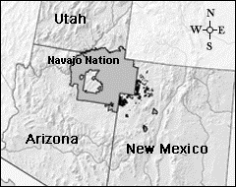
- Teec Nos Pos IHS Clinic 928-656-3294
- Kayenta IHS Clinic 928-697-4000

Navajo Nation
- Behavioral Health
  - Shiprock: 505-368-1050
- Division of Health
  - Window Rock: 928-871-6350
- Even Start, Utah Navajo Development Council 435-672-2311
- Headquarters
  - Window Rock 928-871-6352
  - Aneth Chapter 435-651-3494
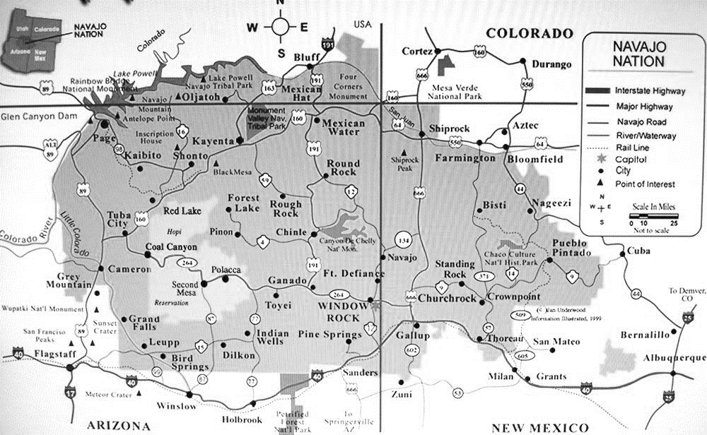
  - Oljato Chapter 435-727-5850
- Medical Center
  - Chinle: 928-674-7001
  - Kayenta: 928-697-4000
  - Shiprock: 505-368-6001
- Navajo AIDS Network
  - Chinle, AZ: 1-888-408-5676
  - Gallup, NM: 505-863-9929
- Navajo Area Agency on Aging
  - Shiprock: 505-368-1250
- Navajo Housing Authority
  - Kayenta: 928-697-3100
- Navajo Nation Utah Commission 435-651-3508
- Navajo Way
  - Window Rock: 928-871-6661
- Office of Special Education and Rehabilitation
  - Window Rock: 928-697-8644
- Office of Scholarship and Financial Assistance
  - Shiprock: 866-223-6457
- Division of Social Services
  - Utah Outreach worker 435-727-5858
  - Kayenta: 928-697-5530
- Utah Navajo Development Council (UNDC), Bluff 435-672-2381
- Utah Navajo Trust Fund (UNTF)
- Blanding: 435-678-1460, 1-800-378-2050
- WIC 1-800-307-4231

COVID-19 Isolation Sites
For members of the Navajo Nation who cannot safely isolate at home. Call your healthcare provider for a referral. Individuals must meet certain requirements.
- Chinle Community Center
- Gallup Wellness Hotel
- Gallup Howard Johnson Hotel

Ute Mountain Ute
- Administration
  - White Mesa 435-678-3397
  - Towaoc: 970-565-3751
- Educational Division 435-678-2035
- Recreation Center 435-678-2118
- Senior Citizens (White Mesa) 435-678-3396
- Ute Mountain Ute Health Center, Towaoc 970-565-444
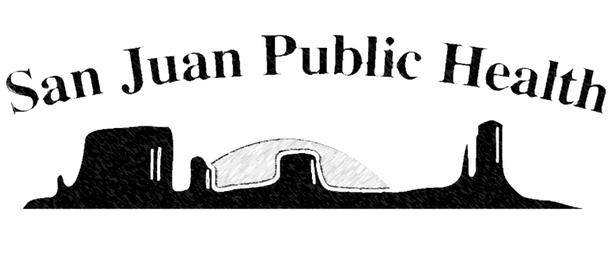
Booklet created by San Juan Early Childhood Coalition and printed by San Juan Public Health
(435) 587-3838 735 S 200 W Suite #2 Blanding, UT 84511 sanjuanpublichealth.org

